TASK # 1: ALGORITHM:
NOTE: Sir due to the difference in format of the docs there is a lack of alignment in this document and it is not also supporting some font type and size as well. Please open the assignment with MS Word for the proper view of the submit task.
Algorithm for paying bill for per person in a restaurant,
START
INPUT Bill(B), People(P), Tip(T)
CALCULATE Tip
T ← B * (T / 100)
CALCULATE TAX
TAX ← B * (Tax / 100)
CALCULATE TOTAL BILL (TB)
TB ← B + T + TAX
CALCULATE bill split to each person
FINAL BILL ← TB / P
PRINT “Each person has to pay rupees” Final Bill
STOP

OPTIMIZED FORM:
START
INPUT Bill(B), People(P), Tip(T)
CALCUALTE bill split to each person
FINAL BILL ← B * (1 + (TAX + T)/100) / P
PRINT “Each person has to pay rupees” Final Bill
STOP
EXPLANATION: Rather than splitting calculation in to different sections. First calculating tax and then calculating tip and then adding them with bill. We will just Apply a single formula calculating all on how much each member has to pay on the basis of the bill given, reducing the algorithm in to a single calculation and then just giving output.

TASK # 2: PAC CHART:

GIVEN DATA | REQUIRED OUTPUT
- Weight  - Height | Body Mass Index (BMI)
CALCULATION REQUIRED | ALTERNATIVE SOLUTIONS
BMI = Weight / (Height * Height) | - Assume weight and height as constant.  - Taking both parameters weight and height as input values.

EXPLANATION: In this problem we fed weight and height as input data for the given data section. Moreover, providing desired output BMI on required output section. Then wrote the formula for its calculation in calculation required section and then wrote the alternative ways we can handle data and produce a viable output.

TASK #3: IPO CHART:
IPO chart for embedding a new notifying system in Snapchat.

INPUT | PROCESSING | MODULE REFRENCE | OUTPUT
Last Snap Time  Current Time | Enter Snap Time  Enter Current Time  Calculate Time Left  Print Time Left  End | Input  Input  Calculate  Print  End | Time Left

EXPLANATION: In this problem, one of the most commonly used app by young people known as Snapchat feature is updated. In this update the app notifies a user how much time is left for the streak to end.

TASK #4: FLOWCHART:
Daily activity of a shopkeeper:
INPUT CASH GIVEN (CG)
START
A
A
D
B
PAYABLE CASH(PC) = CH - PRICE
YES
ELSE
CH >= PRICE
PRICE = PRICE + RC
INPUT RC
INPUT RC
REQUIRED CASH(RC) = CH - PRICE
PRINT “REQUIRED CASH=” RC
ELSE IF
CH <= PRICE
IF
CH == PRICE
STOP
C
D
C
NO
NO
YES
EXPLANATION: This flowchart is based on a daily arithmetic task performed by a shopkeeper and this job is essentially for a cashier in every departmental store.
D
PRICE = PRICE - PC
OUTPUT PC
PRINT “PAYABLE CASH=” PC
B

TASK # 5: PSEUDOCODE:

REPEAT
READ P
IF P <= 0 THEN
EXIT
ENDIF
IF P <100
COMPUTE D P *0.26
ELSE
COMPUTE D P * 0.3
ENDIF
COMPUTE NET_PRICE P – D
PRINT “DISCOUNT:”, D
PRINT “NET PRICE:”, NET_PRICE
UNTIL FALSE
STOP

EXPLANATION: This is Pseudocode for knowing the price and the discount of a book in a book store. This Pseudocode contains the basic structure of loop in it and conditional statements.

TASK # 6: ALGORITHM:

START

INPUT TOTAL_MONEY, TICKET_COST, SNACK_COST

Subtract TOTAL_MONEY TOTAL_MONEY – TICKET_COST

Subtract TOATAL_MONEY TOTAL_MONEY – SNACK_COST

IF TOTAL_MONEY >= 0
PRINT “Purchase Successful”

ELSE
PRINT “Purchase Unsuccessful”

STOP

EXPLANATION: Algorithm for budget management for watching movie. This algorithm contains conditions for estimating the price which will be required. For payment to accomplish this task this algorithm works.

TASK # 7: SCRATCH:

Scratch program for finding radius and circumference of a circle.

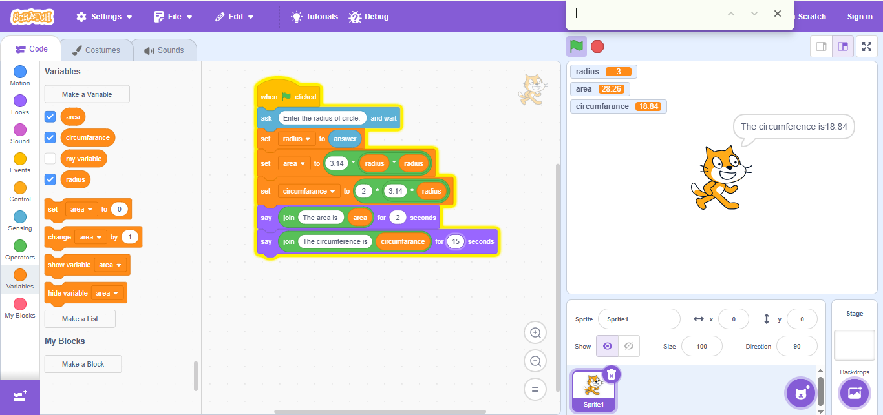
EXPLANATION: The program is written in scratch for printing the area and circumference of the circle. The input required in this program is the radius of the circle. On the basis of the input scratch program calculates the area and circumference of the circle from the operations added in the program.

TASK # 7: SCRATCH:

Scratch program based on a mathematical game for scoring based on input.

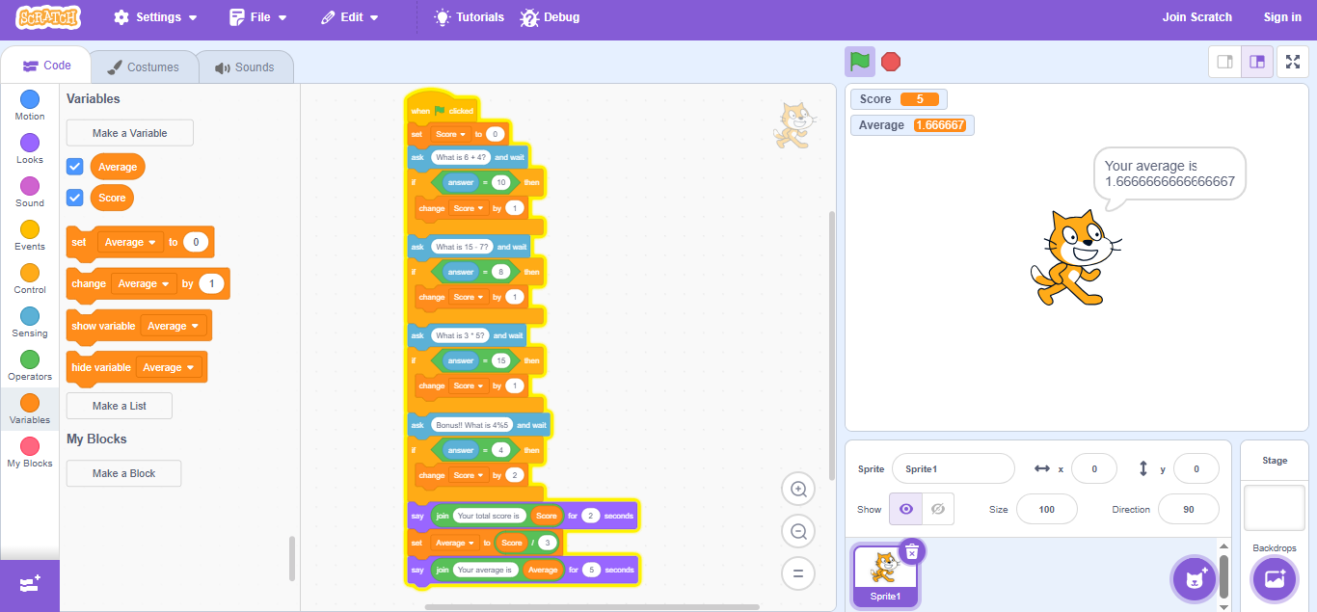

EXPLANATION: This scratch program is based on a game in which the scratch shows a command of mathematical operation and on the bases of this operation the user have to give input it the user is able to give correct answer the score is increased by one, otherwise, the score remains the same. There is also a bonus question which will give two points. Then the program will be able to calculate the average of the score. Score and average will be shown as output.

